

Software Requirement Specification

**for**

TheProject

AUGUST 2018

# 

# Introduction & Background

This document is a Software Requirement Specification (SRS) for the **TheProject**. This is the initial draft for the SRS and it will be used for the extensions.

**TheProject’s**web application aim to provide the opportunities for project seekers and to create a hassle free hiring process for project creators by inducing a trust factor and a trust-coefficient which will be provided by some industry experts.

Students, Freelancers, Job/Avenue seekers can register on the portal, then they can add their skills, certificates, experiences & then go through various evaluations which would all contribute to a rating(or Trust coefficient), a unique feature for employer/avenue creators to take note of.

Employers or Avenue Creators can register on the platform and then search for a candidate according to their requirements.

**TheProject**target audiences are Job seekers, Students, Employers and any one who wants to freelance.

* 1. Purpose

The aim of this document is to specify complete description of web application to be developed. It is the basis for agreement between the developers and user about the product to be developed. Through this document, the workload needed for development, validation and verification will ease.

To be specific, this document is going to describe functionality, external interfaces, performance, attributes and the design constraints of the system which is going to be developed. Therefore, intended reader groups for this software requirement specification are members of **TheProject***,* developers and users.

* + 1. Revision/ Release Number

1.0

* + 1. Vision Statement

The aim of this product is to be the one stop spot for avenue seekers and reduce the unemployment ratio of the market.

* + 1. Scope

This project is intended for making use of internet as a medium for the project creators and project seekers to connect without any difficulties. Currently, there are few websites which provide internship, freelance project and jobs in the market. Usually they provide lots of features to the seekers and creators. However, there is simple but substantial problem with current websites. They are present as individual websites, there is no single platform that provide all three opportunities all together. Also, none of them provide any kind of trust factor to the seeker as well as creator, which poses as the biggest problem for hiring or applying for any vacancy anywhere.

By taking extensive measures we will make everything on the web application foolproof and try to make this process hassle free.

* 1. Document Convention

This document follows MLA Format. Bold - faced text has been used to emphasize section and subsection headings. Highlighting is to point out words in the glossary and italicized text is used to label

* 1. Intended audience and reading suggestion

This document is to be read by the development team, the project managers, marketing staff, testers and documentation writers. Our stakeholders, shareholders of TheProject and distributors who markets the finished product, may review the document to learn about the project and to understand the requirements. The SRS has been organized approximately in order of increasing specificity. The developers and project managers need to become intimately familiar with the SRS.

Others involved need to review the document as such:

* Overall Description – Marketing staff have to become accustomed to the various product features in order to effectively advertise the product.
* System features – Testers need an understanding of the system features to develop meaningful test cases and give useful feedback to the developers.
* External Interface Requirements – The marketing staff also needs to understand the external interface requirements to sell the product by describing the user-friendly features of the TheProject.
  1. Definition, Acronyms and Abbreviations

SRS : System Requirement Specification

MLA: Modern Language Association

* 1. References

**To Be Added**

* 1. Overview

We are going to focus on describing the system in terms of product perspective, product functions, user characteristics, assumptions and dependencies on the following section of this document. Next, we will address specific requirements of the system, which will enclose external interface requirements, requirements of the system, performance requirements, and other requirements.

# 

# Overall Description

This section gives background information about specific requirements of the web based integrated development environment service to be developed in brief. Although we will not describe every requirement in detail, this section will describe the factors that affect the final product.

* 1. Product Perspective

The software product being developed is for all devices which are connected to internet which functions as a platform for all those who are in need of an opportunity to showcase their skills or are looking for a job/internship/freelance projects and also for employers to find reliable and talented workforce easily. The product works with latest technologies like “*Blockchain*” for implementing a trust between our seekers and creators and provide a fair view to all.

This platform uses HTML and CSS for its UI development, backend algorithms are made in java, Database for the platform is developed using Oracle MySQL to store the database of individual profile and is deployed on the Amazon Web Services (AWS) servers for 24/7 hosting of the website.

Currently, there is no other portal, which combines all functionalities and makes use of latest technologies the way the TheProject does. It is the prototype that incubates latest ideas onto a single website.

* 1. Unique Features

Feature inculcated into the product to standout similar products are as follows

* + 1. Trust-coefficient

The rating will be provided through a questionnaire which will be setup and evaluated by the industry experts. This rating gives project seeker visibility and also enhance his opportunities.

Blockchain will be implemented onto the website to maintain the anonymity of the rating system which will be provided by the industry experts. This step is taken to ridicule any chances of any ambiguity into the profile.

* + 1. Career Guidance

This feature will be included under PRO version which will be kept paid, any user who have a paid subscription can take career advices through our experts.

* + 1. Internships with us.

If any user fails to get any internship because of low rating and other product features then we will provide 1 month internship to the user on our own platform.

* 1. Product Function

User interface will be very simple. Project seekers can register on our website and subsequently login and apply for internships/jobs/training courses.

Project creators can register on our website and put forward their opportunities and requirements to choose among the candidates who suit their job the best.

* 1. User Characteristics

Webpage will be accessed by 2 kinds of users as follows :

* + 1. Project Seekers

When the user will click on the login button he/she will be redirected to the login page where after successfully logging in, they can see their dashboard where they can edit their profiles, view job history and apply for new jobs or internships.

* + - 1. Login Process

In order to login as a project seeker, the user needs to enter their correct user credentials set by them earlier. After logging in, they can view or update their records and can view their previous completed works.

* + - 1. Register Process

In order to register as a new user, they must enter all correct details including their full name, email address, mobile number and set a password.

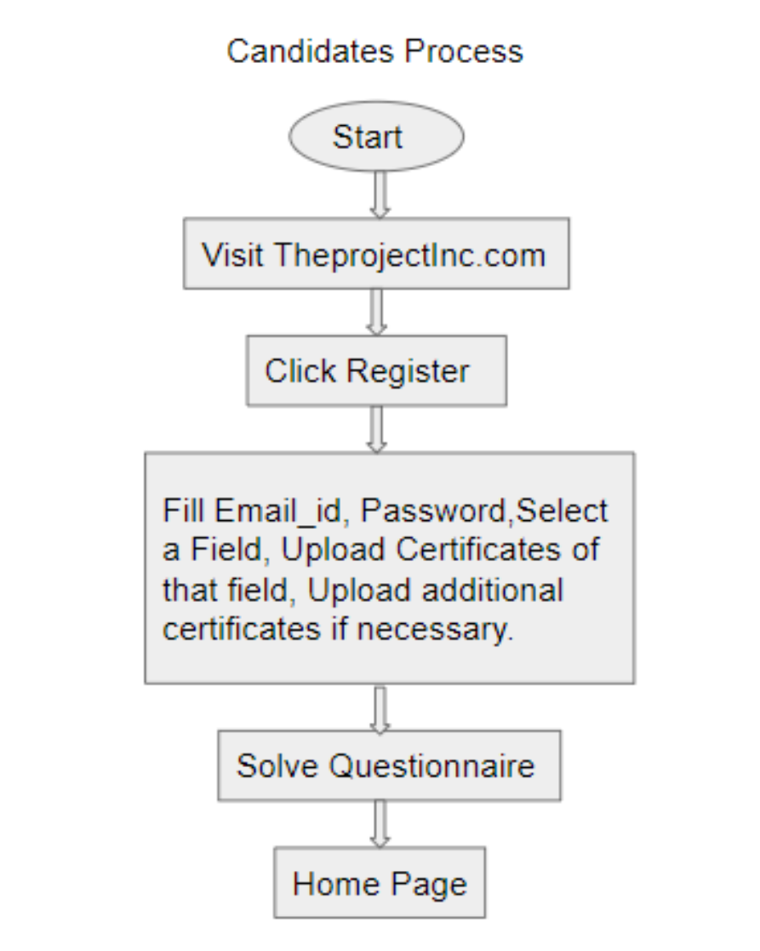

* + - 1. Dashboard  
         Design is yet to be decided
      2. Applying for Jobs or internships

If a user want to apply for the opportunity then he/she will click on the “Get in Touch” tab/button, then he/she will be contacted by the opportunity creator if the user fits the match.

* + 1. Project Creators  
       When project creator will click on the login button, they will be redirected to the login page. After successfully logging in, they will be able to view their dashboard.
       1. Login Process  
          In order to login as a project creator, the user needs to enter their correct user credentials set by them earlier. After logging, they can track the records of their projects and can view their rating or reviews given by project seekers to them.
       2. Registration Process  
          In order to register as a project creator, the user needs to enter their organization/institutions name, full name of the employer, email address associated with the

organization/institutions, mobile number and set a password.   
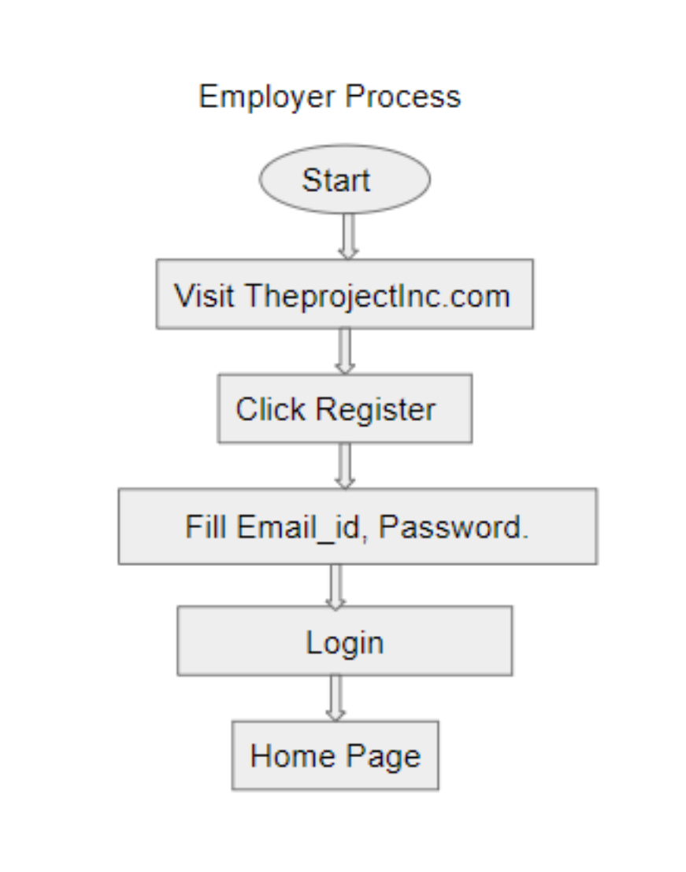

* + - 1. Dashboard  
         After registration they need to upload their organization/institutions legal documents as per requirements of **TheProject.**
  1. Operating Environment

Laptop/PC with a working internet connection and a web browser of latest version.

* 1. General Constraints

a. To be used by any person the website needs to be hoisted.

b. Laptop/PC should be connected to the internet.

* 1. Design and Implementation Constraint

As for now blockchain is not being implemented in our website for the rating system. So, this is a limitation in version 1.0. But in future version we will be implementing blockchain for the same. The mobile app for TheProject.

will be worked upon in the coming future.

* 1. User Documentation

**To Be Added**

* 1. Assumptions and Dependencies
* MySql is a relational database management system which will be used as the main database for our website.
* Hibernate framework will be used as the object relational mapping tool for our project. It will be used for connecting the database with our portal.
* Spring Boot will be used to work in developing the java application. It also supports hibernate in order to develop the application.
* Full working of TheProject is dependent on the availability of Internet connection after the hosting of the website.
* The Blockchain technology will be used for safe and secure transactions including the judgements given by the industry experts for rating purposes.
* HTML and CSS will be used for the front end development part of the web-application.
  1. User Interface

Users can register, login, create jobs and apply for them through their portals of job seeker and job creator. Also, from the dashboard of their portal, the user can update their personal information and their resume and experiences. The project seekers can take restests for their particular fields.

* 1. Hardware Interfaces

The users will need a proper functioning computer system with a working internet connection in it. It will be used to take in input from the user and store it in our database.

* 1. Software Interfaces

The HTML will be used to take in the input from the users which will be saved in H2 using hibernate. Hibernate will also work as a connector between the database and the spring boot. Blockchain will be used to share documents with industry experts for the judgement and rating purposes.

* 1. Communication Interfaces

Primarily, the website will be used as a user interface. In future versions we will also produce a mobile app for the same.

# 

1. **System Features**

Feature inculcated into the product to standout similar products are as follows

* + 1. Trust-coefficient

The rating will be provided through a questionnaire which will be setup and evaluated by the industry experts. This rating gives project seeker visibility and also enhance his opportunities.

* + 1. Questionnaire

A questionnaire will be a set of questions and some coding challenges, the user will have to face to get the rating on the website.

* + 1. Blockchain

Blockchain will be implemented onto the website to maintain the anonymity of the rating system which will be provided by the industry experts. This step is taken to ridicule any chances of any ambiguity into the profile.

* + 1. Special feature to guide students for future

This feature will be included under PRO version which will be kept paid, any user who have a paid subscription can take career advices through our experts.

* + 1. Internships with us.

If any user fails to get any internship because of low rating and other product features then we will provide 1 month internship to the user on our own platform.

# 

1. **Other Non-Functional Requirements**
   1. Security Requirements
      1. Required
2. Web software applications should be developed per secure coding guidelines such as the [Open Web Application Security Project](https://www.owasp.org/index.php/Main_Page) (OWASP) guidelines.
3. Peer-review code with at least one other technically trained individual.
4. Validate all data received via the HTTP Request. Not validating data can result in attacks such as Cross Site Scripting, SQL Injection, HTTP Response Splitting, Log Injection, and Directory Traversal.
5. Validate the data on the server-side. All data (even hidden fields and data from pull down lists) are subject to being modified by a malicious user and should be validated server-side.
6. Pass session IDs and cookies via SSL (HTTPS). Hackers can intercept unprotected session IDs and cookies and use them to compromise the user’s session (session hijacking), and the security of your system.
7. Vulnerability scans should be performed before moving application to production or whenever there are changes to the application.
8. Review the OWASP guidelines. Identify those potential vulnerabilities that may apply to your web application. Review your code and test your application to ensure that your application is not vulnerable.
   * 1. Recommended

### **Recommended:**

1. Web software applications should be developed per secure coding guidelines such as the [Open Web Application Security Project](https://www.owasp.org/index.php/Main_Page) (OWASP) guidelines.
2. Peer-review code with at least one other technically trained individual.
3. Validate all data received via the HTTP Request. Not validating data can result in attacks such as Cross Site Scripting, SQL Injection, HTTP Response Splitting, Log Injection, and Directory Traversal.
4. Validate the data on the server-side. All data (even hidden fields and data from pull down lists) are subject to being modified by a malicious user and should be validated server-side.
5. Pass session IDs and cookies via SSL (HTTPS). Hackers can intercept unprotected session IDs and cookies and use them to compromise the user’s session (session hijacking), and the security of your system.
6. Vulnerability scans should be performed before moving application to production or whenever there are changes to the application.
7. Review the OWASP guidelines. Identify those potential vulnerabilities that may apply to your web application. Review your code and test your application to ensure that your application is not vulnerable. (See the Related Procedures and Resources section below for the link to more detailed information about these software vulnerabilities.)  
   1. Business Rules  
      Only developers are allowed to modify the software and to fix the bugs. This source code cannot be used anywhere without giving credits to the development team (if possible you can give us royalty for using the source code :p)

# 

1. **Other Requirements**

**To Be Added**

# 

# 